Quality Assurance processes during the design, development and implementation of MOOCs can be complex. Quality Assurance (QA) on MOOCs cannot be easily standardised as they have several different aims. Even within one MOOC there are no uniform aims between actors involved (institution, the teaching staff involved and the participants). Moreover, MOOCs are designed for various target groups, and even within 'one target group' the motivation and intention of MOOC participants vary a lot.
Note that QA is a systematic process designed to identify, analyse and eliminate variation (defects) in processes and outcomes. The overall aim is to guarantee a high quality of MOOCs.
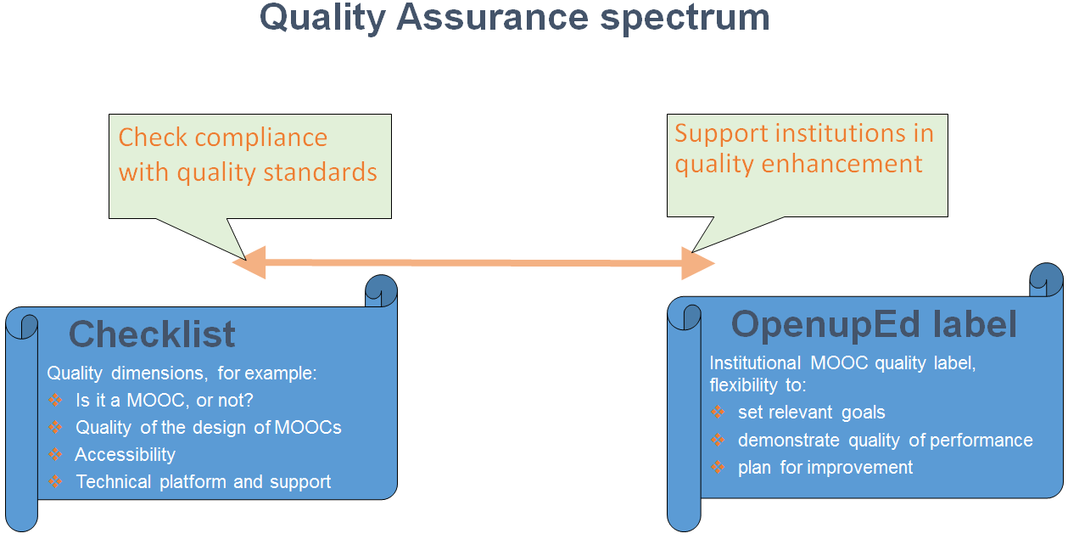
The quality assurance spectrum in general is characterised by:

QA assumes a metric set of standards and best practices. OpenupEd states that quality principles developed for Higher Education (HE) could be used to improve the quality of MOOCs. This ranges from systems which check compliance to norms and often focus on product, to systems that aim at quality enhancement by focusing on process. Most present QA systems for MOOCs are characterised by externally set norms, whereas with the OpenupEd Label, institutions have embedded processes aimed at quality enhancement towards their own objectives.
In this spectrum new OpenupEd partners are expected to achieve the OpenupEd Label within three years after entry. Upon entry the MOOC offering of the institutions is checked with some basic checklists based on several standards and best practices.
On the next page these checklists are presented for the following dimensions:
- Is it a MOOC or not?
- Quality of the design of MOOCs
- Accessibility
- Technical platform and support for staff and participants
New partners are expected to self-assess their MOOC offering accordingly and submit the completed checklist (with an official letter for becoming OpenupEd partner).

Checklist 1: Is it a MOOC or not?
OpenupEd adopted the following definition of a MOOC, as developed by many European MOOC initiatives:
“An online course designed for large numbers of participants that can be accessed by anyone anywhere as long as they have an Internet connection, are open to everyone without entry qualifications and offer a full/complete course experience online, for free.”

Table 1. Review “Is it a MOOC or not?”
Levels: NA (Not achieved) ; PA (Partially achieved) ; LA (Largely achieved) ; FA (Fully achieved)
Dimension | Criteria | Is it a MOOC or not?
 |  | NA | PA | LA | FA
Massive | The (pedagogical model of the) course is such that the efforts of all services (including of academic staff on tutoring, tests, etc.) does not increase significantly as the number of participants increases
Open | Course accessible to (almost) all people without limitations
 | At least the course content is always accessible
 | Course can be accessed anywhere as long as someone has an internet connection
 | No qualifications / diplomas needed to participate in the online course
 | Full course experience without any costs for participants
Online | All aspects of the course are delivered online
Course – study unit | The total study time of a MOOC is minimal 1 ECTS ((25-30 hours of study)
Full course | The course offers a full course experience including:
 | educational content may include Video – Audio - Text – Games (incl. simulation) – Social Media – Animation
 | offers possibilities for interaction, such as social media channels, forums, blogs or RSS readers to build a learning community
 | participants are provided with some feedback mechanism. Can be automatically generated (e.g., quizzes), only by peers (peer feedback) and/or general feedback from academic staff, etc.
 | always includes some kind of recognition like badges or a certificate of completion. A formal certificate is optional and most likely has to be paid for
 | study guide / syllabus includes instructions as to how you may learn from the presented materials and interactions

Checklist 2: Quality of the design of MOOC

Table 2. Review “Quality of the design of MOOC?”
Levels: NA (Not achieved) ; PA (Partially achieved) ; LA (Largely achieved) ; FA (Fully achieved)
Dimension | Criteria | Design of MOOC
 |  | NA | PA | LA | FA
Target group | MOOCs are accessible to all people and as such various target groups are identified
 | For each target group the needs, challenges and prior knowledge are described
 | The description of each target group is supported by references different studies
Overall goal | The overall objective of the course is described in a few sentences
Learning objectives | The course describes a limited number of learning objectives
 | A clear statement of learning outcomes for both knowledge and skills is provided
 | There is reasoned coherence between learning outcomes, course content, teaching and learning strategy (including use of media), and assessment methods
 | The prior knowledge of each learning objective is described and related to characteristics of target groups
Learning activities | Activities aid participants to construct their own learning and to communicate it to others
 | The "pathways" (activities, tasks and routes) are designed in such a way that they can be performed at different levels of difficulty or complexity, to account for the broad spectrum of participants’ knowledge and skills that is expected
Various activities are proposed with different formats.
For example: quizzes, peer-to peer evaluation, video conferences (Google+/Hangouts), activities in the forums and platform social networks or external social network (Facebook, Twitter, Goole +)
 | The MOOC contains differing levels of difficulty, with different learning pathways
 | The course contains sufficient interactivity (learner-to-content, learner-to-learner or learner-to-teacher) to encourage active engagement.
Feedback mechanism | Feedback by an academic tutor is limited and scalable (characteristic of MOOC).
 | The course provides learners with regular feedback through self-assessment activities, tests or peer feedback.
 | The frequency of monitoring been planned (forum, group, post)
 | A weekly announcements or massive mailing with orientations for the following week is planned.
 | In each weekly session, the pedagogical team makes a synthesis of artefacts from the previous week’s session.
 | Some live-events (Hangout, Tweetchat) are scheduled
Study-time | The total study time of all learning activities (including quizzes, tests and exam) is minimal 1 ECTS (25-30 hours of study)
Workload | The schedule of the course is such that the workload per week is feasible for typical learners from the specified target group (typical 6-8 hours for those with full-time jobs)
 | The MOOC is realistic in its pacing for the participant, accommodating to the individuals personal rhythm
Assess-ment | Learning outcomes are assessed using a balance of formative and summative assessment appropriate to the level of certification
 | Assessment is explicit, fair, valid and reliable. Measures appropriate to the level of certification are in place to counter impersonation and plagiarism
 | Participants can earn badges for completion of learning activities
 | The MOOC has possibilities to follow the score and progression

Checklist 3: Accessibility

Table 3. Review “Accessibility of MOOC”
Levels: NA (Not achieved) ; PA (Partially achieved) ; LA (Largely achieved) ; FA (Fully achieved)
Dimension | Criteria | Design of MOOC
 |  | NA | PA | LA | FA
Web-accessibility | Compliant to W3C accessibility
 | Compliant to WCAG 2.0 according to EC
Accessible Information | Implemented the Guidelines for Accessible Information
 | The introduction videos are subtitled / transcripted
 | Participants are able to download, store, and use resources without an internet connection
Accessible learning | Implement the Guidelines from Universal Design for Learning

Checklist 4: Technical platform and support for staff and participants

Table 4. Review “Technical platform and support for staff and participants”
Levels: NA (Not achieved) ; PA (Partially achieved) ; LA (Largely achieved) ; FA (Fully achieved)
Dimension | Criteria | Design of MOOC
 |  | NA | PA | LA | FA
Platform | The MOOC platform is reliable, secure and assures appropriate levels of privacy. Provision is made for system maintenance, monitoring and review of performance
 | The MOOC platform provides a range of online tools which are appropriate for the educational models adopted
Staff support | The institution provides appropriate training for academic and support staff to develop the skills required to develop and deliver MOOCs
 | The institution provides adequate support and resources to MOOC staff and manages workloads appropriately
 | MOOC participants are provided with clear and up-to-date information about courses including aims/objectives, learning and assessment methods, workload and prerequisite knowledge
Support for MOOC participants | Participants have access to their personal learning environment, follow progression, tasks, completion, badges, and publications
 | The institution uses social networking media to foster academic communities among MOOC participants
 | MOOC participants have clear routes to academic, technical and administrative support
 | The participant assisted by a technical guide for good navigation
 | In addition a FAQ is in place to support participants navigation
 | The participant is assisted by pedagogical guidelines for good learning
 | A list of criteria for the learning activities, specifically for peer to peer evaluations, is available

